IT2120- Probability and Statistics
Lab6
IT24103297

Question 1
Part 1
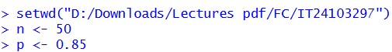

Part 2

Question 2
Part 1
Part 2
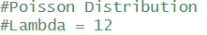

Part 3
